Option #2: Failed Improvement Project Memo
First, read the failed improvement project
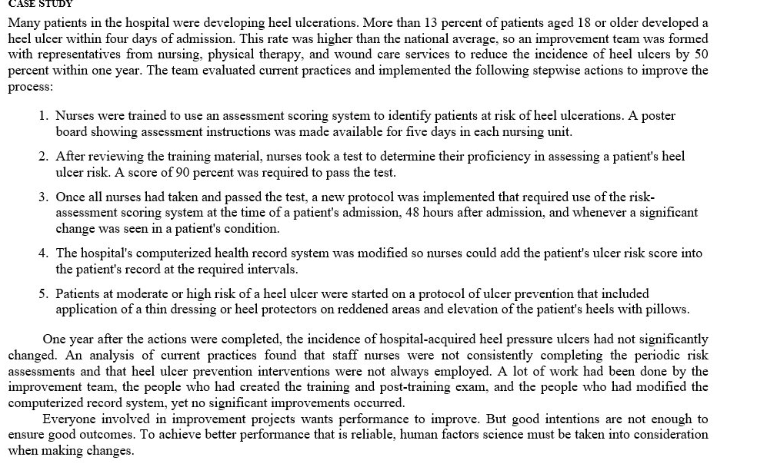
Then, conduct a literature review and Internet search for risk reduction strategies aimed at preventing and managing heel ulcerations.
For this assignment, you will write a brief memo addressed to the Chief Nursing Officer. In the memo, identify and discuss two or three specific process changes that could be implemented to achieve 80 to 90 percent reliability in preventing and managing heel ulcerations. Then identify and discuss two or three additional process changes that would be needed to reach 95 percent reliability. Finally, discuss how you would measure the effectiveness of the changes.
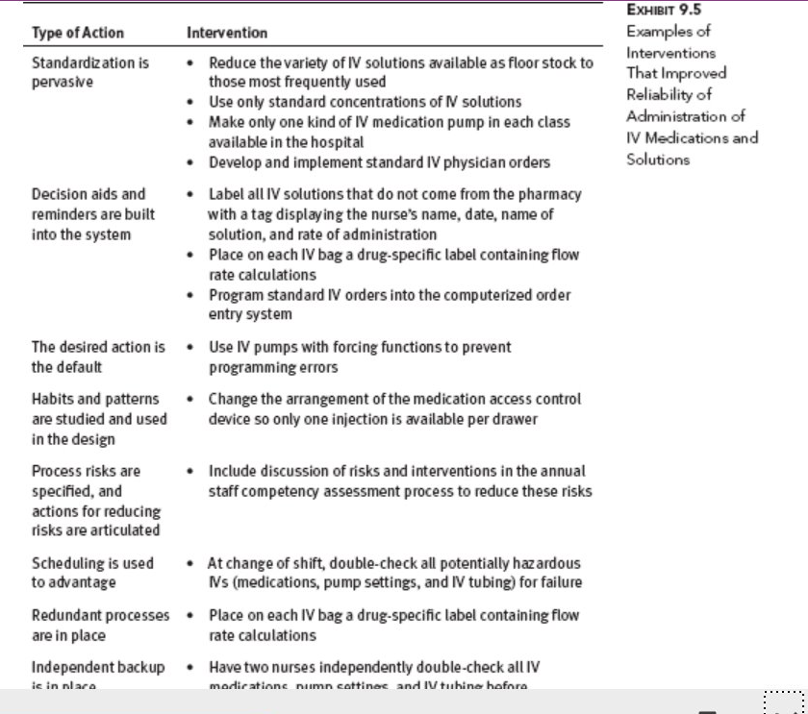


The memo should be well-written and meet the following requirements:
- Be two pages (single-spaced) in length plus a title page and a reference page
- Includes at least three references from the peer-reviewed articles. The CSU-Global Library is a good place to find peer-reviewed articles.
- Conforms to CSU-Global Guide to Writing and APA

